TITLE OF PAPER

Principal Author, Company*, Additional Author (if any), Company, Additional Author (if any), Company
*Company., Address, City, Province, Postal Code, firstname.lastname@email.ca

Introduction (Use Heading 1 in Styles)

First paragraph (Use Normal in Styles; Ensure 5 spaces at the start of each new paragraph). There is a 15-page maximum allowance which includes all tables and figures. Double space between text and Tables and Figures.

The use of acronyms to abbreviate long expressions is encouraged by the Water Environment Association of Ontario (WEAO). When appropriate, an appendix defining the notations used should be included after the Acknowledgement section or explained after the first usage of the acronym. The Author should always try to use commonly accepted notation.

All data in the text, figures and tables must use metric notation and standard SI nomenclature. It is the author’s responsibility to supply necessary conversions. If desired, English units may follow the metric quantities in parentheses. Refer to, WEF MOP 6, “Units of Expression for Wastewater Management” for guidance.

Use double space between paragraphs. Examples of Table and Figure are provided below.

Table 1: Example
Heading | Heading | Heading
Info | Info | Info

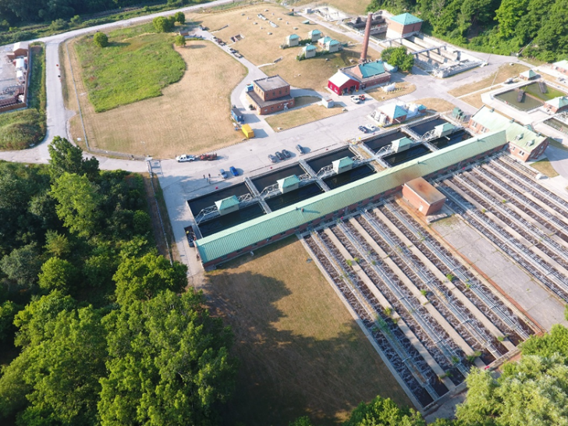
Figure 1: Sample image for reference

$$A=πr^{2}$$
where: A = area
π = pi the ratio of a circle’s circumference to its diameter (3.1415) $r^{2}=radius$

Equation 1: sample of an equation

Second paragraph

Subheading (Use HEADING 2 in Styles)

First paragraph

Second paragraph

Methodology

First paragraph

Second paragraph

Results

First paragraph

Second paragraph

Discussion

First paragraph

Second paragraph

Conclusions

First paragraph

Second paragraph

Acknowledgement

First paragraph. Work performed under previous auspices should be stated in the Acknowledgement section of the paper. The first paragraph of the acknowledgement section may also include credits for funding of, or assistance in the study.

Bibliography

The list should be in alphabetical order of the author's surnames. All authors should be listed, i.e., do not use "et. al.". The order of items in each reference is to be as follows:
- Author(s);
- Year of publication;
- Title of work;
- Periodical;
- Publisher;
- Conference;
- Etc.; and,
- Volume number and page, if appropriate.

You may wish to refer to the Water Environment Research journal for sample citations. An example is below.

Jones. A.B., and Smithe, C.D. (1992a) Treatment of hazardous wastes in wastewater treatment plants. Water Environ. Fed., 64, 999.

